Abstract Template for CECAR 10 (Title)

Gildong GO¹, Chul-Soo KIM², and Ilhan CHANG^{3*}

¹ Ph.D. Student, Dept. of Archeology, Dooly University, Seoul, Republic of Korea
² Professional Engineer, Construction Division, Kajima Corporation, Tokyo, Japan
³ Associate Professor, Dept. of Civil Systems Engineering, Ajou University, Suwon,
Republic of Korea
* Corresponding author; e-mail: cecar10cu@jeju2025.korea

ABSTRACT: A one-page abstract should be prepared in the following format: Use a sheet of A4 size. The main text of the Abstract should be 300 to 500 words long. Figures and tables can be inserted. Use 14 points bold Calibri for title. Use 12 points Times New Roman for author’s names and affiliations. Title and author's names should be centered. Use 12 points Times New Roman for corresponding author’s contact (e-mail). Insert one blank line between the affiliations and the main text. Use 11 points Times New Roman for the Abstract main text. Main text line spacing should be fixed at 15 pts. Include representative graphical items (Figure or Table) on the same page. If necessary, graphic elements can be positioned horizontally. The Abstract file should be in Word format. Deadline for submission of Abstract is August 20, 2024.

Table 1 CECAR history

No. | Year | Organized by
CECAR1 | 1998 | PICE
CECAR2 | 2001 | JSCE
CECAR3 | 2004 | KSCE
CECAR4 | 2007 | CICHE
CECAR5 | 2010 | EA
CECAR6 | 2013 | HAKI
CECAR7 | 2016 | ASCE
CECAR8 | 2019 | JSCE
CECAR9 | 2022 | ICE(I)
CECAR10 | 2025 | KSCE
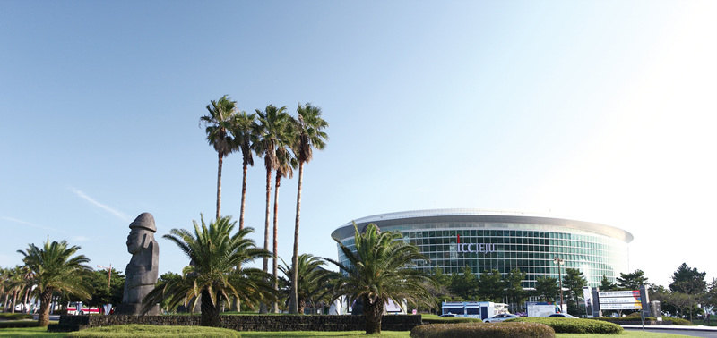

Fig. 1 Conference venue: ICC JEJU

