Extended Abstract (Full Paper) Template for CECAR 10 (Title)

Gildong GO¹, Chul-Soo KIM², and Ilhan CHANG^{3*}

¹ Ph.D. Student, Dept. of Archeology, Dooly University, Seoul, Republic of Korea
² Professional Engineer, Construction Division, Kajima Corporation, Tokyo, Japan
³ Associate Professor, Dept. of Civil Systems Engineering, Ajou University, Suwon, Republic of Korea
* Corresponding author; e-mail: cecar10cu@jeju2025.korea

ABSTRACT: An extended abstract or a full paper should be prepared in the same format as follows: Limits on the length of an extended abstract is up to 2 pages and of a full paper is up to 15 pages, Use A4-size sheets, Use 14-point Calibri bold for title, Use 12-point Times New Roman for author’s names and affiliations, Title, author's names, and affiliations should be centered, Insert one blank line between the affiliations and the main text, The Abstract should be 300 to 500 words long, and Use 11-point Times New Roman for the Abstract and the main text. Deadline for full paper submission is January 31, 2025.

1. HEADINGS (INDENT LIKE THIS SAMPLE IF IT IS LONG)
(1) Main heading
Capital letters in 12pt boldface fonts should be used for main headings (chapter titles) that follow the chapter numbers as is shown in this example.

(2) Sub-headings for sections
The sub-headings for sections, in 11pt boldface fonts, with their initial letters capitalized, are preceded by parenthesized section number like (2).
a) Sub-headings for sub-sections
They are written just as the sub-headings for sections are done, but follow alphabets with right parentheses. No spacing of lines is left before and after every sub-heading.

2. MATHEMATICS
Use special high-quality fonts for all mathematical equations in the text. Some equations may be placed off the text as:
(1a)
(1b)
and some appear in the text as C_{D}, (z). Numbered equations ((1a) and (1b) for example) should be center-aligned. The equation numbers in parentheses should be placed flush right.

3. FIGURES AND TABLES
(1) Location of figures and tables
Figures, tables, and photographs should be inserted at the upper or lower part of the page where reference is first made to them. Do not place them altogether at the end of the manuscript. Do not place any text besides figures or tables. Insert about one to two lines of spacing above the main text.

Table 1 CECAR history

No. | Year | Organized by
CECAR1 | 1998 | PICE
CECAR2 | 2001 | JSCE
CECAR3 | 2004 | KSCE
CECAR4 | 2007 | CICHE
CECAR5 | 2010 | EA
CECAR6 | 2013 | HAKI
CECAR7 | 2016 | ASCE
CECAR8 | 2019 | JSCE
CECAR9 | 2022 | ICE(I)
CECAR10 | 2025 | KSCE
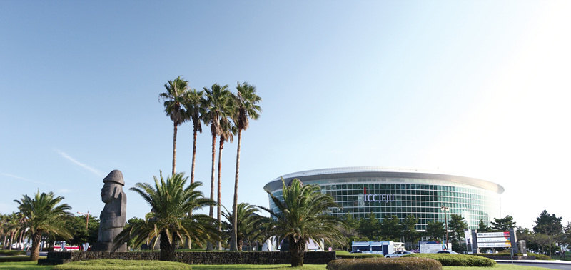

Fig. 1 Conference venue: ICC JEJU

(2) Fonts and captions
Do not use too small characters in figures and tables. At least, the letters should be larger than those in the captions (9 pt.). Captions should be centered like an example of Fig. 1 and Table 1. The heading of captions is 11pt boldface.

4. CITATION AND REFERENCE LIST
All the references must be in parentheses and used in the text (Ghai et al., 2016) where it is referred to like this (Cuenca, 2014). The reference list must be summarized at the end of the main text and sorted alphabetically.

5. CONCLUSIONS

ACKNOWLEDGMENT: Acknowledgment should follow Conclusions.
This work was supported by the National Research Foundation of Korea (NRF) grant funded by the Korea government (MSIT) (No. 1711188748).
REFERENCES
Chang, I. and Cho, G.C. (2019), Title of the paper, Title of the journal (Volume:Issue numbers), pp. 123-456.
Chang, I. and Cho, G.C. (2019), Shear strength behavior and parameters of microbial gellan gum-treated soils: from sand to clay, Acta Geotechnica (14:2), pp. 361-375.
Chang, I., Im, J., Prasidhi, A.K., and Cho, G.C. (2015), Effects of Xanthan gum biopolymer on soil strengthening, Construction and Building Materials (74), pp. 65-72.

